Project 1: Explore Weather Trends

**Outline of steps taken to prepare data:**

1. Extract/Export city data for my city (select * from city_data where city=’Miami’)
2. Extract/Export all global data (select * from global_data)
3. With Excel, viewed both datasets and removed rows that contained empty values. (Miami had several years without known temperatures)
4. Excel: Calculated 3 day moving average and 7 day moving average (using the 7 day moving average for next steps though) using =AVERAGE(startcell:endcell)
5. Before creating visualizations I needed to make sure I can show the trends from both data sets in one visual for better comparison. Added both datasets into one file.
6. Created line chart where I used the years starting at 1781 (due to missing values in previous years for Miami) and the 7 day moving average.
7. Made observations in comparing the two trends as noted below

**Line Chart Screenshot:**

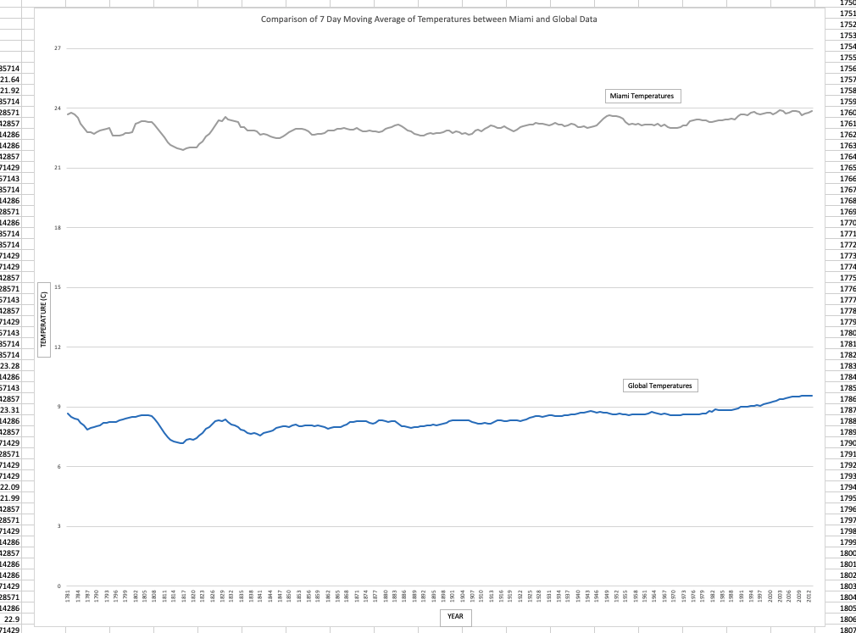

**Screenshot of moving averages equation used in Excel:**

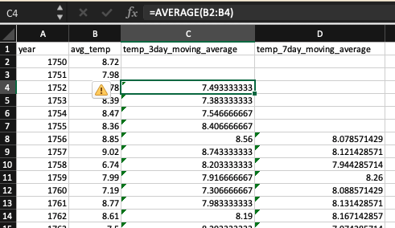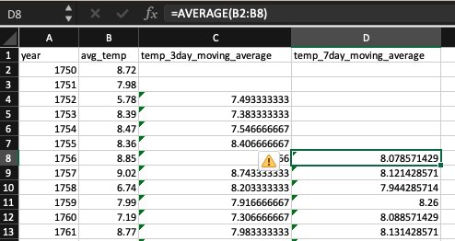

**Observations Made:**

1. The Miami temperature 7 day moving average and the Global Temperature 7 day moving average move upwards and downwards mostly together through the years.
2. The Miami temperatures are much warmer than the Global temperatures. This is probably due to Miami’s location.
3. Since Miami’s temperatures are much higher, there must be other temperatures in other locations that are much lower than the Global Temperatures.
4. Over the past 220+ years, the temperatures for Global moving averages have slowly trended upwards. In other words, it’s warmer in 2015 than it was in 1781.